CV

`

OBAIDULLAH

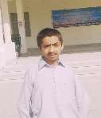📞0326-9273645

✉[obaidullahdone123@gmail.com](mailto:obaidullahdone123@gmail.com)

📍 Ubauro, Pakistan

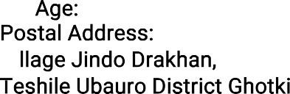

❖

22

📞 



* To work in organization where I can fully utilize my knowledge to achieve the

highest efficiency and strive to promote the status organization and to improve myself.



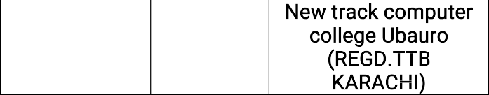

HOBBIES:

* READING BOOKS
* To develop and enhance my skills in MS Office
* CIRCKET, VOLLEY BALL

LANGUAGE:

* ENGLISH
* URDU
* SINDHI